**MODs Aquarium App**

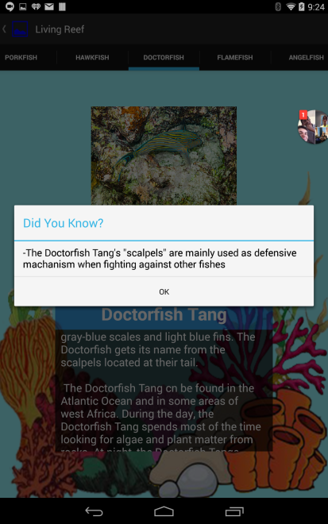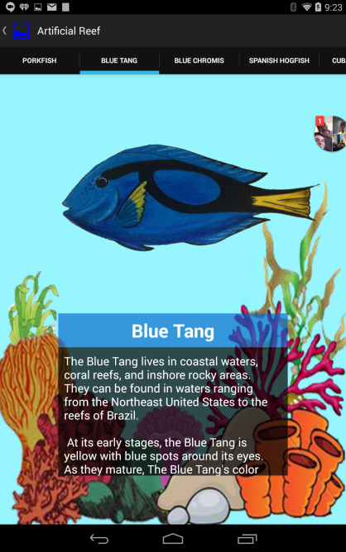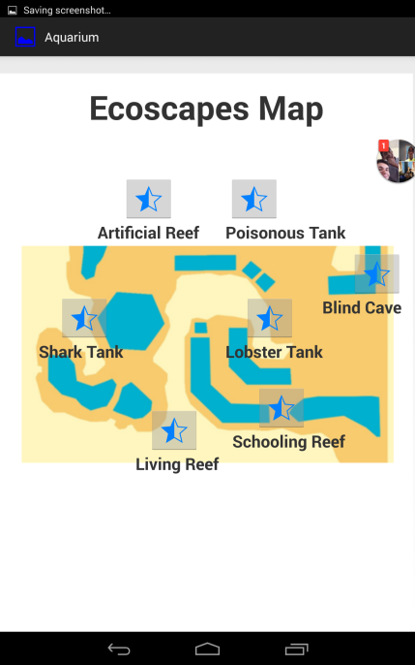**In this app, there are 7 different stars each representing different locations of different exhibits on a map. Each location displays a certain type of animals. Once users click on a star, they are now able to view the types of animals are that displayed in that exhibit. With each animal the viewer can read a short 1-2 paragraphs in a scrollable text box at the**  **bottom of the screen about it and scroll horizontally to view the other animals available in that exhibit. Users can also tap on the animal to read a special “Did-You-Know” fact, which displays special facts about the animal that tapped on. This app also has a button in the top right corner. When users click on it, it opens a drop-down menu that displays a tab called “Settings.” However, when users tap on it, nothing happens.**

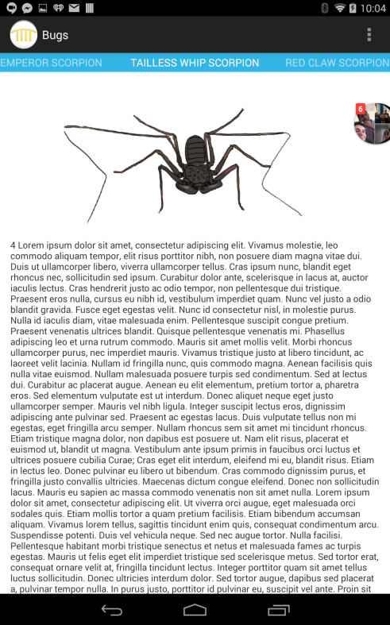**MODs Bug App**

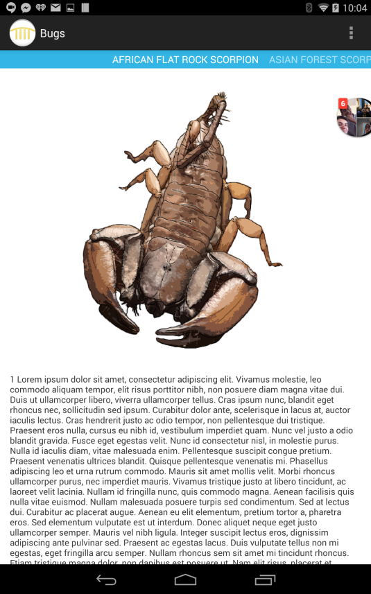 **This app is similar to the aquarium app but offers fewer features. It only displays a picture of the bug and generic scrollable text that the user can view. There is also an action bar so the user can swipe horizontally between each bug, and each text is labeled with a number so the bugs are organized in numeric order, increasing. Users can also click on the three circles on the top right corner to open a drop down menu with a tab called “Settings.” However, when users click on the tab, nothing happens.**

**Detection Robot**

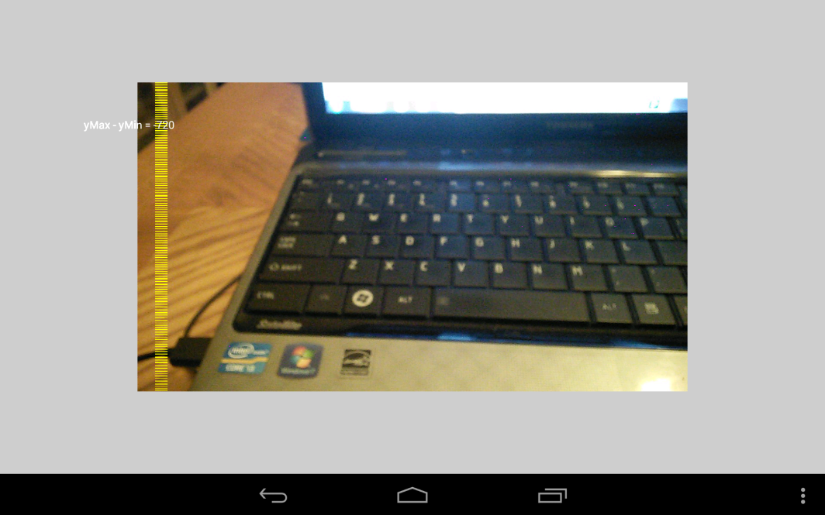 **When this app is first launched, it displays a blank white screen. However, when user taps on the screen, it opens up a camera that runs at 10 frames per second, as indicated by the code. When the user taps again, it takes a picture. Once a picture is taken, it begins analyzing it for green pixels. Using the RGB color scheme, it shades in purple dashes for any region containing green pixels captured by the picture taken by the camera.**

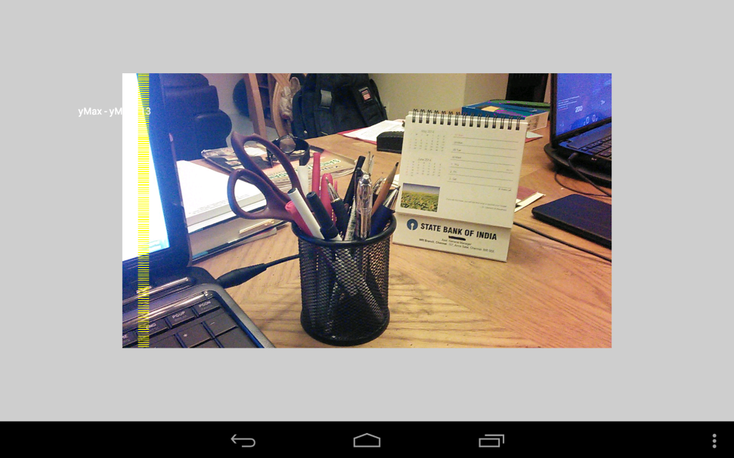**This robot can also calculate distance. Using the image it takes captured by its camera. It calculates the farthest region containing green pixels and returns the distance from the camera in cm. When the program is run, it is shown as white text next to yellow dashes. It first prints the text “yMax – yMin:” followed by the distance. In this case, the distance was 113 cm.**